**Project Proposal**

**Project Link**

* For our Risk Management project, here are the accounts for each member on GitHub. Dylan Glass: [djg5812](https://github.com/djg5812), Jason Buitrago: [jayhchd](https://github.com/jayhchd), Justin Printz: [jap6300](https://github.com/jap6300), Quijhanae Lee: [qlee-1](https://github.com/qlee-1).
* Here is the link to our GitHub page: https://github.com/orgs/SRA311
* The project manager for our team will be Dylan Glass. Email: djg5812@psu.edu, Phone number: 610-914-9413.

**Executive Summary**

* The organization we are doing our risk analysis on will be Uber.
* Major assets using the SHEL model for Uber can be identified as such:
  + Liveware: Personnel (this includes the drivers, customers, and corporate).
  + Hardware: Vehicles and headquarters.
  + Software: Mobile application, checklist for drivers and customers, and work procedures for drivers.
  + Environment: Headquarters for the personnel. Being outside or inside a vehicle for drivers and customers.
  + Liveware-Liveware (L-L) interface: Personnel (the drivers and customers) interacting with each other.
  + Liveware-Environment (L-E) interface: Personnel (drivers) being inside the headquarters. Personnel (drivers and customers) being outside or inside a vehicle.
  + Liveware-Software/Hardware (L-S/H) interface: Personnel (drivers and customers) using the mobile application as the software. Personnel (drivers and customers) using the headquarters or vehicles.

Some of the major security challenges that Uber can face could include but is not limited to hacking in the mobile application or website, customer canceling the ride midway (customer gets free ride; driver does not get paid), and more.

* For our risk management model, we are going to use the NIST model. The way that we followed this framework in our analysis is by first identifying the organization (Tier 1), in this case Uber. Then we will identify the mission/business process (Tier 2) of the organization, in this case is by purchasing a ride through the application and then receiving the ride by the driver. Then we will identify the information system (Tier 3) of the organization, in this case it is wherever the driver submits the request at and the drop-off location they want to go to.
* The benefits our project can bring to the organization can include security flaws that we found when going in depth in research, potential decrease in the value of assets for stakeholders, possible internal and external problems, and more. The possible constraints for our analysis can include not having the information of exact numbers for the assets that could affect the stakeholders, legal issues that could occur, budget issues regarding the company, and more.

**Background Information**

* Information about Uber:
  + Name of Organization: Uber Technologies, Inc formally UberCab
  + Basic Information:
    - Industry Sector: Transportation
    - CEO: Dara Khosrowshashi
    - Management/Board Personnel: Nelson Chai (Chief Financial Officer), Tony West (Chief Legal Officer), Nikki Krishnamurthy (Chief People Officer), Andrew Macdonald (Senior Vice President, Mobility & Business Operations, Sundeep Jain (Vice President, Product), Jill Hazelbaker (Senior Vice President, Marketing and Public Affairs), Eric Meyhofer (Head of Advanced Technologies Group), Bo Young Lee (Chief of Diversity and Inclusion Officer.
  + Number of Employees: 22,000+
  + Number of Branch Offices: 1 office, which happens to be the headquarters, located in San Francisco, CA
  + Organizational Structure:

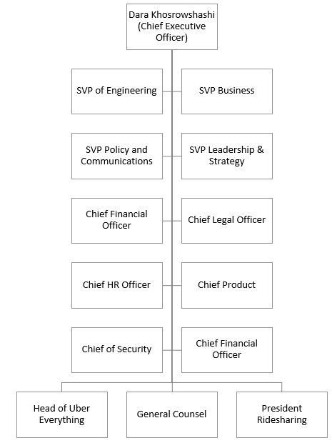

* + Manufacturing Facilities: Asia: Bangalore, Gurgaon, Hyderabad, Manila, Melbourne, Singapore, Sydney, and Tokyo; Europe: Aarhus, Amsterdam, Limerick, London, Madrid, and Paris; Latin America: Bogota, Buenos Aires, Mexico City, Santiago, and Sao Paulo; Middle East and Africa: Cario, Dubai, Johannesburg and Nairobi; U.S & Canada: Austin, Chicago, LA & Santa Monica, NY, Phoenix, Pittsburgh, San Francisco Bay, Seattle, Washington D.C and Toronto
  + Important Product Lines: Uber’s ride options: UberX, Uber Pool, Uber Comfort, Uber Green, Uber Black, Bikes, Uber Scooter, Uber Bikes, UberXL, Uber Transit, Uber WAV, Uber Lux, Uber Black SUV, Uber Taxi, Uber Flash, Uber Auto and Uber Air.
* Out of the options listed above in the “Important Product Lines”, 3 of the most popular product lines include UberX, Uber Pool, and Uber Comfort. UberX is an option for riders who plan to ride with uber and has a family. UberX was designed so that parents using Uber felt comfortable when riding with infants and/or toddlers, making it so that additional riders do not have to deal with a distressed child. Uber Pool is another option that Uber offers customers. The idea behind Uber Pool was to make riding with Uber as affordable as possible. When choosing Uber Pool as an option, customers can expect to experience a joint ride with a minimum of one additional customer or more. Lastly, Ubers mission behind Uber Comfort was to create a spacious and comfortable ride option for customers that may travel from city to city, state to state or even locally. Uber has thoroughly thought out each product line with the intentions of satisfying all customers' needs and wants.
* The essential business functions the organization we think could include but is not limited to Corporate espionage, software, stocks, physical safety, lawsuits, mobile application and website. Out of the functions listed, the 3 we are going to be focusing on include Corporate espionage, software, and stocks.

|  |  |  |
| --- | --- | --- |
| Corporate espionage flowchart | Software flowchart | Stocks flowchart |
|  |  |  |

**Stakeholder Analysis**

* In the image below, this presents the information about the major stakeholders.

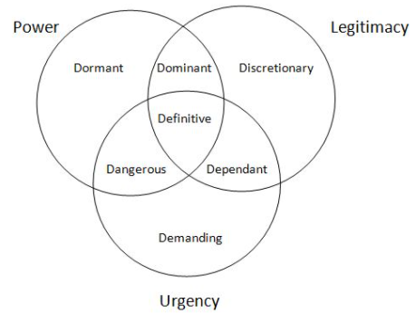

* Refer to the image above for the stakeholder types.
* Our stakeholders are interested in seeing the company succeed. By presenting this risk assessment, it could show the stakeholders that Uber watches over the financial part of the business, along with the security and safety of others.
* When it comes to the stakeholders, this includes everybody that has either invested in stocks, works for the company, customers, etc., they are all affected by the changes that Uber makes. Mentioned previously, the stakeholders want to see the company succeed. By making changes that better the company, this will increase the profits for everybody that is involved financial with the company.

**Project Scope Statements**

* Business functions: mobile application/website, software, and stocks.
* We are focusing on these functions because they are what allow Uber to run as a company. If Corporate espionage occurs within the company, certain information that is taken could become public. This also affects the software because if there is a breach within the mobile application/website, sensitive information could be exposed and leaked. If both business functions are affected, it could cause the stocks to drop in value which could ultimately affect Uber as a whole.

|  |  |  |
| --- | --- | --- |
| Functions | Assets | Input and Output |
| Corporate espionage | Employees, stakeholders, customers | Input: Someone spies  Output: Company gets bad reputation |
| Software | Data, employees, end users | Input: Coders work on the backend  Output: Better usability for the users |
| Stocks | Financial, stakeholders | Input: Someone invests  Output: Stock goes up |

* Following Jens Rasmussen’s categories, the possible security incidents which can happen to these functions could include: Corporate espionage: This is categorized under “Accidents of Category 3”. This occurs very rarely and can have a huge impact on the company. Software: This is categorized under “Accidents of Category 2”. This occurs often and has more severe consequences. Stocks: This is categorized under “Accidents of Category 1”. This occurs daily as stock prices are changing on the daily.

**Preliminary Risk Analysis**

* The main major security gap on the business procedures for our company would be Corporate espionage. If there was a spy within the company that was leaking out information, this is a security problem as there is not a separation of powers within the company. This would cause people to not trust the company which could cause the stocks to drop in price.

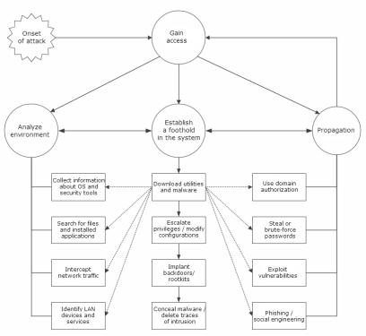

<https://securelist.com/security-holes-in-corporate-networks-network-vulnerabilities/67452/>

* Qualitative Risk Analysis

|  |  |  |  |
| --- | --- | --- | --- |
|  | Consequence 1 (Low) | Consequence 2 (Medium) | Consequence 3 (High) |
| Probability 1 (Low) | Somebody spies on company | Somebody spies on company but doesn’t leak data | Somebody spies on company and leaks data |
| Probability 2 (Medium) | Software has a small glitch | Software has bigger issues but still not major | Software breaks and no longer works |
| Probability 3 (High) | The stock fluctuates throughout the day | Stocks start changing dramatically and stakeholders start selling | Stocks drop significantly and stakeholders leave the company |

* Qualitative Risk Analysis Frequency Likelihood

Risk <= 2 Low Risk

Risk <= 4 Medium Risk

Risk > 4 High Risk

|  |  |  |  |
| --- | --- | --- | --- |
|  | Consequence 1 (Low) | Consequence 2 (Medium) | Consequence 3 (High) |
| Probability 1 (Low) | Risk = 1*1 | Risk = 1*2 | Risk = 1*3 |
| Probability 2 (Medium) | Risk = 2*1 | Risk = 2*2 | Risk = 2*3 |
| Probability 3 (High) | Risk = 3*1 | Risk =3*2 | Risk = 3*3 |

* For corporate espionage to prevent someone from spying on the company the company could increase their security and use separation of powers. For software use the company could hire more people to work on the backend coding to fix bugs. For stocks the company could release something new like news or information that could cause the stock to raise.

**Data Collection and Analysis**

* The data that is needed in order to estimate the frequency likelihood and impact of the risks in our analysis could include
* <https://investor.uber.com/home/default.aspx> (Financial Reports), <https://s23.q4cdn.com/407969754/files/doc_financials/2019/ar/Uber-Technologies-Inc-2019-Annual-Report.pdf> (Financial Statements), <https://www.uber.com/> (General Information).

|  |  |  |
| --- | --- | --- |
| Names | Descriptions | Statistic Distributions |
| Uber | Provides financial reports along with general information about Uber. | As numbers change on the daily, this will be updated the day before submission of the project. |
| United States Securities and Exchange Commission (SEC) | Provides financial statements about Uber. | As numbers change on the daily, this will be updated the day before submission of the project. |

**Development Plan**

|  |  |  |
| --- | --- | --- |
| **Due Date** | **Activity** | **Responsible Member** |
| September 25 | Look at project proposal and brainstorm ideas | Dylan, Quijhanae, Justin, Jason |
| October 9 | Finish project proposal and submit | Dylan, Quijhanae, Justin, Jason |
| October 15 | Work on “Executive Summary” section | Dylan, Quijhanae |
| October 22 | Work on “Background Information of the Organization” section | Justin, Jason |
| October 29 | Work on “Stakeholder Analysis” section | Dylan, Quijhanae |
| November 5 | Work on “Project Scope Statements” section | Justin, Jason |
| November 6 – December 5 | Work on “Risk Analysis” section | Dylan, Quijhanae |
| December 6, 7 | Work on presentation and practice the presentation | Dylan, Quijhanae, Justin, Jason |
| December 14 | Project Final Paper | Dylan, Quijhanae, Justin, Jason |